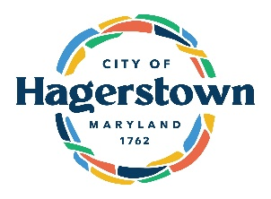
City of Hagerstown
32 N POTOMAC ST SUITE 100
Hagerstown, MD 21740
301.739.8577 EXT 823

Water and/or Wastewater Bill Adjustment Request Form

*Please note: Quarterly bills older than 3 quarters are not eligible for adjustments. Monthly bills older than 6 months are not eligible for adjustments. *

Name on Account: ________________________________
Account Number: _______________________________
Service Address: _________________________________
Telephone Number: _______________________________
E-mail Address: __________________________________

Leak Information – state when leak was discovered and brief description of the leak:
____________________________________________________________________________________________________________________________________________________________________________________________________________________________________________________________________________________________________

Repair Information– description of repairs made and REQUIRED: attach copy of plumber’s invoice and/ or receipts for parts:
________________________________________________________________________________________________________________________________________________________________________________________________________________________________________________________________________________________________________________________________________________________________________

I am requesting for an adjustment on my water/wastewater utility bill number ______________________ (state bill number) due to a water leak. I attest that all the information above is accurate to the best of my ability.

_______________________________ ____________________
Signature of Owner/Prop Mgmt co Date

Please return by mail or in person at 32 N POTOMAC ST SUITE 100, or email to BillingMail@hagerstownmd.org or fax to 301.797.6173. Adjustments are not processed same day. Please keep in mind, tenants cannot authorize an adjustment application.

Mayor
William McIntire

Council
Kristin Aleshire
Caroline Anderson
Erika Bell
Tiara Burnett
Sean Flaherty

City Administrator
Scott Nicewarner

City Clerk
Donna K. Spickler

Director of Utilities
Nancy Hausrath

Electric Division
Nathan Fridinger
425 East Baltimore St.
301.739.8577 ext. 143

Fax: 301.739.7958

Wastewater Division
1 Clean Water Circle
301.739.8577 ext 650
Fax: 301.733.2873

Water Division
51 W. Memorial Blvd.
301.739.8577 ext. 680
Fax: 301.733.7482

